IW-15
YEAR 9 SCIENCE
CHEMICAL SCIENCES
TEST 1 - ATOMIC STRUCTURE, RADIATION

NAME: CLASS: Mark: 

All matter is made of atoms that are composed of protons, neutrons and electrons; natural radioactivity arises from the decay of nuclei in atoms.

Multiple Choice Write the answer to each question in the appropriate box at right.

1. γ, β, α, B

IN ORDER, the above symbols mean:

A Gamma, Beta, Alpha, Boron.
B Gamma, Boron, Alpha, Beta.
C Alpha, Beta, Gamma, Beryllium.
D Alpha, Beryllium, Gamma, Beta.
QUESTION | ANSWER
1
2
3
4
5
6
7
8
9
10
11
12
13
14
15
16
2. The nucleus of which atom is identical to an alpha particle?

A H - Hydrogen
B He - Helium
C Li - Lithium
D Ti - Titanium

3. Which of the following statements about atoms is true?

A An atom is mostly empty space.
B Neutrons and protons are found in the nucleus with the electrons.
C Electrons circle the nucleus all the time.
D The number of neutrons found in the nucleus of an atom is always the same.

4. The mass number of an element is the total number of:

A electrons in an atom.
B protons in an atom.
C protons and electrons in an atom.
D protons and neutrons in an atom.

5. The atomic number of an element is the total number of:

A electrons in an atom.
B protons in an atom.
C protons and electrons in an atom.
D protons and neutrons in an atom.
6. An atom contains 4 protons, 5 neutrons and 4 electrons. Its mass number is:

A 4
B 5
C 9
D 13

7. An atom contains 4 protons, 5 neutrons and 4 electrons. Its atomic number is:

A 4
B 5
C 9
D 13

8. A charged atom is called:

A an isotope.
B an ion.
C a proton.
D radioactive.

9. Define ionising radiation:

A Radiation from the ionosphere.
B Radiation produced when atoms are ionised.
C Any type of electromagnetic radiation.
D Radiation that can remove electrons from atoms and molecules.

10. Identify the set that contains an element, a compound and a mixture.

A Carbon dioxide, air, silver.
B Gold, sulfur, phosphorus.
C Granite, oxygen, hydrogen.
D Copper oxide, calcium carbonate, sodium chloride.

11. Beta particles are:

A fast-moving electrons.
B positively charged.
C heavier than an alpha particle.
D unable to penetrate human skin.

12. One of the particles inside the atom is very much lighter than the others. It is the:

A electron.
B neutron.
C nucleus.
D proton.

13. The nucleus of the atom contains:

A only neutrons.
B only protons.
C electrons and neutrons.
D neutrons and protons.

14. Which of the following are atoms of the same element?

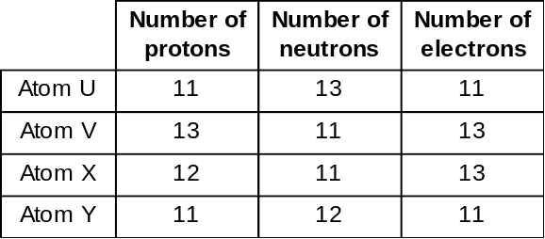

A U and Y
B U and X
C X and Y
D U and V

15. Different isotopes of the same element contain different numbers of:

A electrons.
B neutrons.
C protons.
D nuclei.

16. Iodine -131 has a half-life of 8 days. If a sample of I-131 has a mass of 60 g, how much radioactive iodine will be left after 16 days?

(a) 7.5 g
(b) 15 g
(c) 30 g
(d) 3.75 g

Short Answer Write the answer to the questions in the spaces provided.

1. Complete the following table.

ELEMENT | PROTONS | NEUTRONS | ELECTRONS
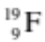
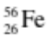
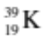

(3)

2. What makes the nuclei of some atoms naturally unstable?

(1)
3. The graph below shows the radioactive decay of iodine-131.

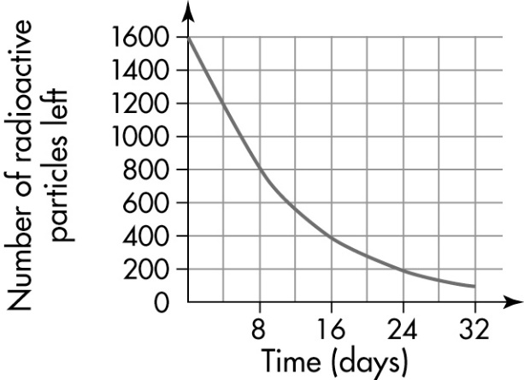

(a) What is the half-life of iodine-131?

(1)
(b) How many radioactive particles would be left after 40 days?

(1)

4. List two major long-term effects on humans caused by cell damage resulting from exposure to large amounts of nuclear radiation.

•

•

(2)

5. Describe two uses of nuclear radiation in medicine and/or industry.

•

•

(2)

